SUCCESSES AND HIGHLIGHTS:

UNTIL THE VIOLENCE STOPS: NYC, which took place June 12-27, successfully took over the five boroughs of the city, inviting New Yorkers to stand up and join V-Day in making New York City the safest place on earth for women and girls.

With startup support from The Rockefeller Foundation and lead corporate support from Verizon, sponsors included Avon Foundation, Bloomberg, CBS Outdoor, Suca by Susan Cappa and The Lakshmi Foundation.

During a two-week festival of theater, spoken word, performance and community events, UNTIL THE VIOLENCE STOPS: NYC:

- Raised $1.1 million dollars
- Sold out 4 events reaching 4,250 people
- Welcomed 2,000 runners in Prospect Park running to demand an end to violence
- Witnessed 50 actresses and over 100 writers contributing their genius, time and talent
- Joined 70 community events in all five boroughs reaching 1,000’s of people
- Held 1 press conference with Mayor Michael Bloomberg
- Placed 2,000 messaging posters on buses and subways in all five boroughs
- Made millions of media impressions from editorial coverage in outlets including: The New York Times, The Associated Press, The Amsterdam News, Time Out NY, Metro, New York Daily News, Access Hollywood, Al Jazeera, Good Day New York, Queens Times, The Brooklyn Eagle, Womens Enews, and many more
- Reached over 8 million people who heard and saw the message that ending violence against women and girls is possible

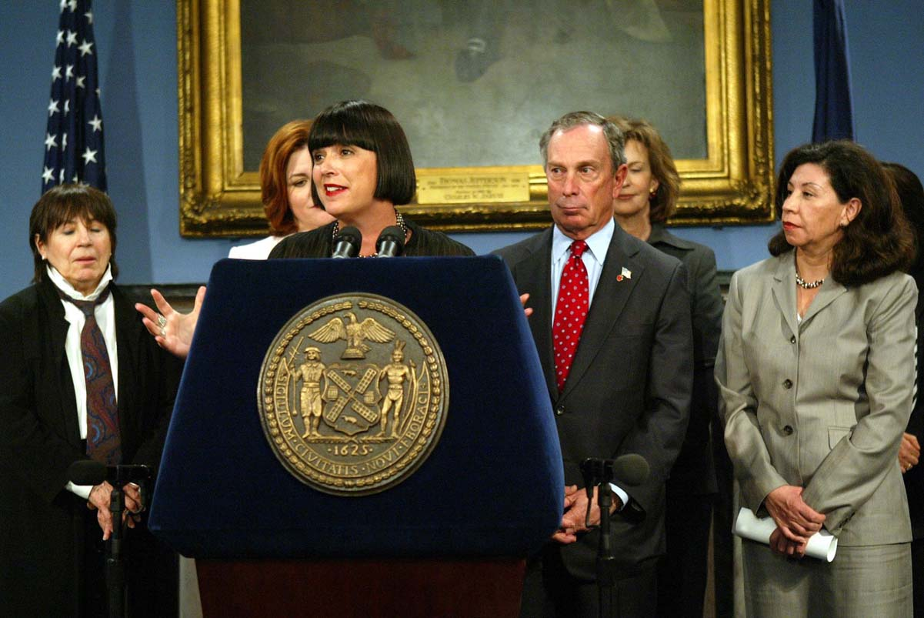

UPDATES AND RESULTS:

“(82%) of festival attendees reported that attending the event made them want to take action to reduce violence against women and girls.” This amazing statistic comes from the independent evaluation by MATRIX Public Health Consultants, Inc., that was generously commissioned by The Rockefeller Foundation. Highlights from their findings follow.

Like the V-Day model established with The Vagina Monologues, UNTIL THE VIOLENCE STOPS was designed to be replicated. In the summer of 2007, V-Day’s Until The Violence Stops Festival will be presented by V-Day organizers in Ohio and Kentucky, bringing together women’s groups in those states to stand strong and demand an end to violence in their communities. The events will highlight local talent and anti-violence organizations. V-Day’s campaign directors are providing guidance and support. Paris, Denver, and Providence, Rhode Island are among the cities planning festivals in Summer 2008!
Also in June 2007, Villard will release the anthology A Memory, A Monologue, A Rant, and A Prayer. Proceeds from its sale will benefit V-Day. From the Villard catalogue:

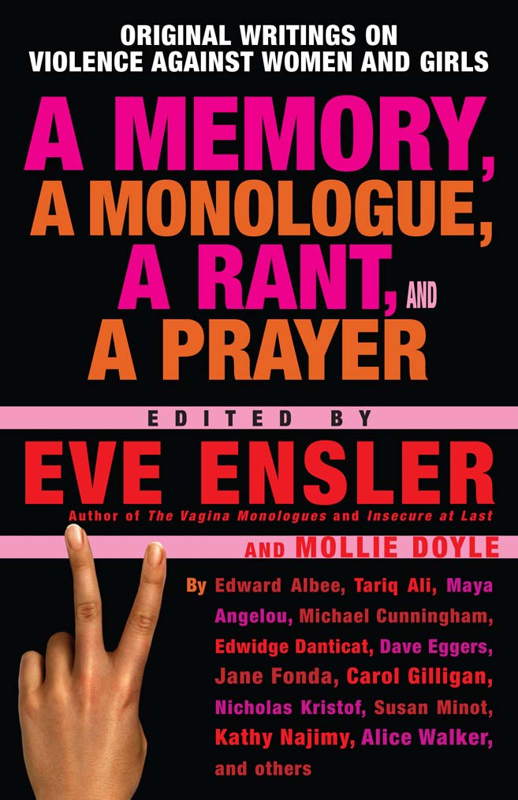 |  |  | When her stage play The Vagina Monologues became an international sensation (“probably the most important piece of political theater of the last decade” The New York Times), Eve Ensler emerged as a powerful voice and champion for women everywhere. The Vagina Monologues was Phase One of her international V-Day project; with Until the Violence Stops, she unveils Phase Two. This impressive, illuminating, inspired collection of pieces from  Ensler’s sold out internationally bound “Until the Violence Stops” festival of theater, spoken word,  and community events brings the issue of violence against women and girls to the forefront of our consciousness. From Edward Albee on S&M to Edwidge Danticat on a border crossing to  Nicholas Kristof on the limitations of being a  journalist to Carol Gilligan on a daughter  watching a mother get hit to Sharon Olds on  a bra, these sad, funny, heartening, tragic,  brilliant, and scary writings offer a true and  profound portrait of how violence against women  and girls affects us all.

In conjunction with the book release, local V-Day organizers will stage readings of A Memory, A Monologue, A Rant, and A Prayer, as originally performed during UNTIL THE VIOLENCE STOPS: NYC. The essays make for a powerful evening of theater and action. Tentative cities: Chicago; Los Angeles; San Francisco; Miami; New York City; Denver; Boston; Toronto; Houston; Hartford.

A benefit performance of Necessary Targets will take place in Beirut and London. The Beirut event will feature Jane Fonda and will be held at the First Beirut Conference On Women that V-Day is sponsoring with the Arab League and Al Hasnaa magazine.
In a wonderful statement about ending violence, the winner of Run Until The Violence Stops was gun survivor and official “Millionth Face” in Amnesty International’s Control Arms Campaign Julius Arile Lomerinyang from Kenya. Julius won the 5K race in just over 16 minutes!

Manhattan Borough President Scott M. Stringer issued a Proclamation to V-Day Founder/Artistic Director Eve Ensler, commending her for her tireless efforts to end violence against women and girls and for bringing V-Day’s mission straight to the streets of Manhattan with UNTIL THE VIOLENCE STOPS: NYC.


FESTIVAL FINDINGS:

An independent evaluation by MATRIX Public Health Consultants, Inc. was commissioned by The Rockefeller Foundation.

Following is a summary of their findings:

UNTIL THE VIOLENCE STOPS: NYC General Impact

- 1.1 million dollars was raised to support local organizations in the fight to end violence towards women and girls.

- V-Day marquee events were highly successful in increasing the public’s knowledge and awareness of the impact of violence against women and girls and of how they might contribute to the fight to end it through personal action.

- While 38% of informants assumed violence against women and girls is a “given”, the vast majority of community event attendees (82%) reported that attending the event made them want to take action to reduce violence against women and girls.

- The festival content and materials were thoughtful, provocative, and covered major components of the issues surrounding violence against women and girls, including: 1) root causes 2) manifestations; 3) consequences; and 4) potential solutions. The main performances of the festival were delivered by high-caliber artists, writers and performers reflecting racial and ethnic diversity. Furthermore, in raising awareness about potential action steps to end the violence, the festival has served as a catalyst to mobilize individuals to take (further) action.

- Previous work in advertising suggests that the materials generated for the festival with strategic placement on buses, subway stations and in subway cars in NYC made possible approximately 2 million impressions.

- The ad campaign was visually appealing and primarily informative about the festival

- In addition to the ad campaign and website coverage, it is estimated that millions of media impressions were made via print media coverage of the festival. Sources with information/articles about V-Day include The New York Times, Democracy Now, Time Out New York, The Nation, Pucker Up, NYCLU, The Amsterdam News, The Brooklyn Eagle, Women’s Enews, Access Hollywood, New York Daily News, Metro, Al Jazeera, Good Day New York, Queens Times, and RenewAmerica. The content published by these sources ranged from purely informational, to transcripts of recorded interviews, to op-ed articles for the campaign. Independent media served as V-Day’s major media outlet.

- Estimates of the reach of UNTIL THE VIOLENCE STOPS: NYC are broad and may be based on the composite of various sources including the ad campaign, festival activities and newsprint

impressions and suggest that over 8 million people may have heard something/learned something about ending violence towards women and girls. This estimate is approximate and is based on:
- Potentially 2 million ad campaign impressions (potentially 2 million individuals)

- Potentially 6 million print media impressions (including newspaper and websites)
- 4,000 marquee event participants
- 2,000 runners
- 2,900 V-Day survey participants (pre-and post street intercept surveys and community event surveys)

- Performer feedback was overwhelmingly positive in terms of planning and support.

- Estimates of the reach of the ad campaign on the NYC population was 28% (based on random sampling of the general population using street intercept surveys post-UNTIL THE VIOLENCE STOPS: NYC) suggesting that the ad campaign was successful in reaching approximately one-third of the general population in its current format.

UNTIL THE VIOLENCE STOPS: NYC Impact on Attendees

- A select sample of approximately 4,000 individuals received intensive messages about violence against women and girls including statistics, root causes, consequences, solutions and action steps through their participation in the marquee events. Of the 1,000 that completed surveys, 60% reported that they had learned something new, and 81% reported that they are willing to take or have taken action in the form of raising awareness, assisting victims, volunteering, donating funds and/or political action.

- The audience was very receptive, interactive and engaged with the presenters. It was multigenerational and included former batterers, victims, activists, and intervention groups

- Violence against women had personally impacted the majority of their lives (72%) and one third of them think about it often. One-half of informants (49%) reported that violence against women and girls affects their daily activities and choices.

UNTIL THE VIOLENCE STOPS: NYC Impact on Community-Based Organizations (CBO)

- A large number of the community venues had high levels of audience participation and included presentations by survivors of violence and activists against violence.

- Diverse themes were covered at the community events and addressed youth, elderly, family, relationships, friendships, domestic violence, and court processes.

- The majority of the audience at the community events reported they learned something new by attending the event (75%).

- There was overwhelming positive feedback from the CBOs about the expansiveness of the outdoor media campaign produced by V-Day.

- The CBOs used the online calendar of events and agreed that it increased attendance at their events

- All CBO key informants reported above-average attendance at their community events and more diverse attendees than normal in terms of gender, age, and ethnicity.

- New CBOs felt that having an event(s) associated with V-Day brought them critical stakeholders, increased their membership base, and networked them more firmly to the existing local CBO community.

UNTIL THE VIOLENCE STOPS: NYC V-Day Men Feedback

- The majority of participants agreed that male leadership is essential at both the national and community level to stop violence against women; persons in a variety of positions are ‘natural leaders’ including school teachers, coaches, police, religious leaders, political leaders, media representatives, fathers, and “anyone with power in terms of communication.”

- The participants reported they learned facts about violence, action steps and male identity.

RECAP OF THE FESTIVAL:

From June 12 – 27, 2006, UNTIL THE VIOLENCE STOPS: NYC, a festival of theater, spoken word, performance and community events, brought the issue of violence against women and girls front and center in the culture and the community.

Produced by V-Day and conceived by its founder Eve Ensler, the festival took over New York City, putting women, their empowerment and safety directly on center stage. Ensler’s vision was to stop New Yorkers in their tracks and for two weeks have the issue of violence against women on people’s minds by having events and information available to them to explore and learn about the violence that affects one in three women in the U.S. and around the world.

With marquee events, performances by celebrated actors, original works by noted authors, community events throughout the five boroughs, a citywide messaging campaign, and a run through Prospect Park, UNTIL THE VIOLENCE STOPS: NYC issued a call to action to all New Yorkers, and to the world: Demand an end to violence against women and girls and become an active participant in ending it.

“Through V-Day, we have witnessed the power of art to transform and galvanize change. It’s time to be bold, to amplify our efforts and to take our movement to end violence against women to the next level.
V-Day was born in New York City and UNTIL THE VIOLENCE STOPS: NYC took our message directly to the people of New York. Together, we will make New York City the first safe place for women and girls,” stated Ensler.

Founded in 1998 on the principle that art inspires activism, V-Day is a global movement to end violence against women and girls that raises funds and awareness through benefit productions of Ensler’s award winning play The Vagina Monologues. V-Day is a catalyst that promotes creative events to increase awareness, raise money and revitalize the spirit of existing anti-violence organizations. V-Day generates broader attention for the fight to stop violence against women and girls, including rape, battery, incest, female genital mutilation (FGM) and sexual slavery.

Through V-Day campaigns, local volunteers and college students produce annual benefit performances of The Vagina Monologues to raise awareness and funds for anti-violence groups within their own communities. In 2006, over 2700 V-Day benefit events took place produced by volunteer activists in the U.S. and around the world, educating millions of people about the reality of violence against women and girls.

Performance is just the beginning. V-Day stages large-scale benefits and produces innovative gatherings, films and campaigns to educate and change social attitudes towards violence against women including the documentary Until the Violence Stops; community briefings on the missing and murdered women of Juárez, Mexico; the December 2003 V-Day delegation trip to Israel, Palestine, Egypt and Jordan; the Afghan Women's Summit in Kabul; the March 2004 delegation to India; the European Organizer Workshop in Brussels in March 2005; the Stop Rape Contest, the Indian Country Project, and Love Your Tree.

To date, the V-Day movement has raised over $40 million and educated millions about the issue of violence against women and the efforts to end it, crafted international educational, media and PSA campaigns, launched the Karama program in the Middle East, reopened shelters, and funded over 5000 community-based anti-violence programs and safe houses in Kenya, South Dakota, Egypt and Iraq.

V-Day events have taken place in all fifty United States and in over 112 countries from Egypt to Australia to Kenya to the Philippines. The 'V' in V-Day stands for Victory, Valentine and Vagina.

Today, V-Day is a model of empowerment philanthropy and public awareness, inviting women and men to use art and performance to raise funds and awareness in their own communities. This New York City-focused campaign utilized the key elements of performance and theater to raise consciousness and funds and increase the dialogue about violence against women locally, nationally and globally.

Joined by artists and community organizations, V-Day worked to raise the awareness level in New York City concerning the issue of violence against women and girls, educate people about the issue, and encourage citizens to take action to end it. We are poised at a historic moment for women and girls around the world, and the festival was an unprecedented opportunity to create change around the issue of violence against women and girls.

Elements of the Festival:

MESSAGING CAMPAIGN
For six weeks, a citywide outdoor advertising campaign took over New York City’s buses, subway cars, subway platforms and street banners urging New Yorkers to “Make NYC The Safest Place On Earth For Women And Girls.” The campaign appeared throughout the five boroughs inviting all New Yorkers to join V-Day in the effort to end violence against women and girls.

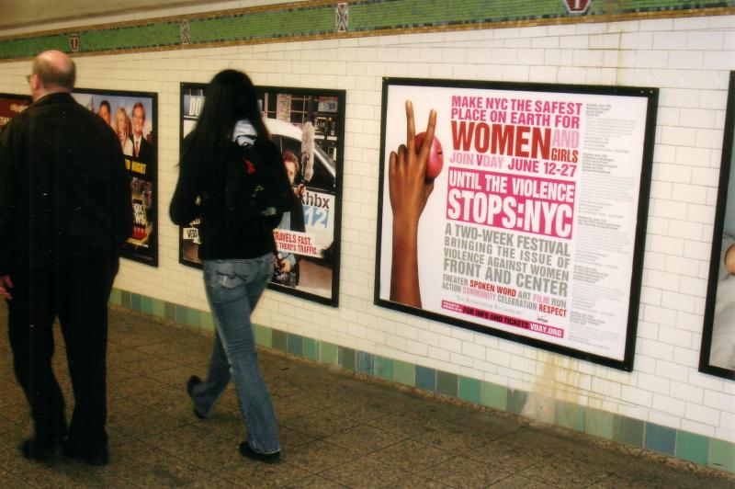

COMMUNITY EVENTS IN ALL FIVE BOROUGHS
V-Day convened a group of local organizations working to end violence against women and girls in their communities. The working group of over 50 anti-violence and community groups coordinated local events throughout all five boroughs. This grassroots coalition was sponsored by the Avon Foundation.

“The event exceeded our expectations with the number of attendants and the money we raised. Around 300 people showed up and close to $18K was raised. The most special aspect was to bring awareness to a crowd we've never been able to reach before. Even with such a ‘heavy topic’ the feedback was that
people really had a great time, and words such as ‘inspirational’,‘educational’ and ‘amazing’ will keep us moving continuously towards stopping violence against women. The art of surviving was fun and powerful!”
- UNTIL THE VIOLENCE STOPS Community Event Organizer & Mt. Sinai SAVI Advocate

“We've heard from several survivors who want to join VOW or need help and 3 men contacted Connect or VOW to ask for help with their abusive behavior.”
- Voices of Women Organizing Project

MARQUEE EVENTS

Necessary Targets by Eve Ensler
June 12 at Studio 54

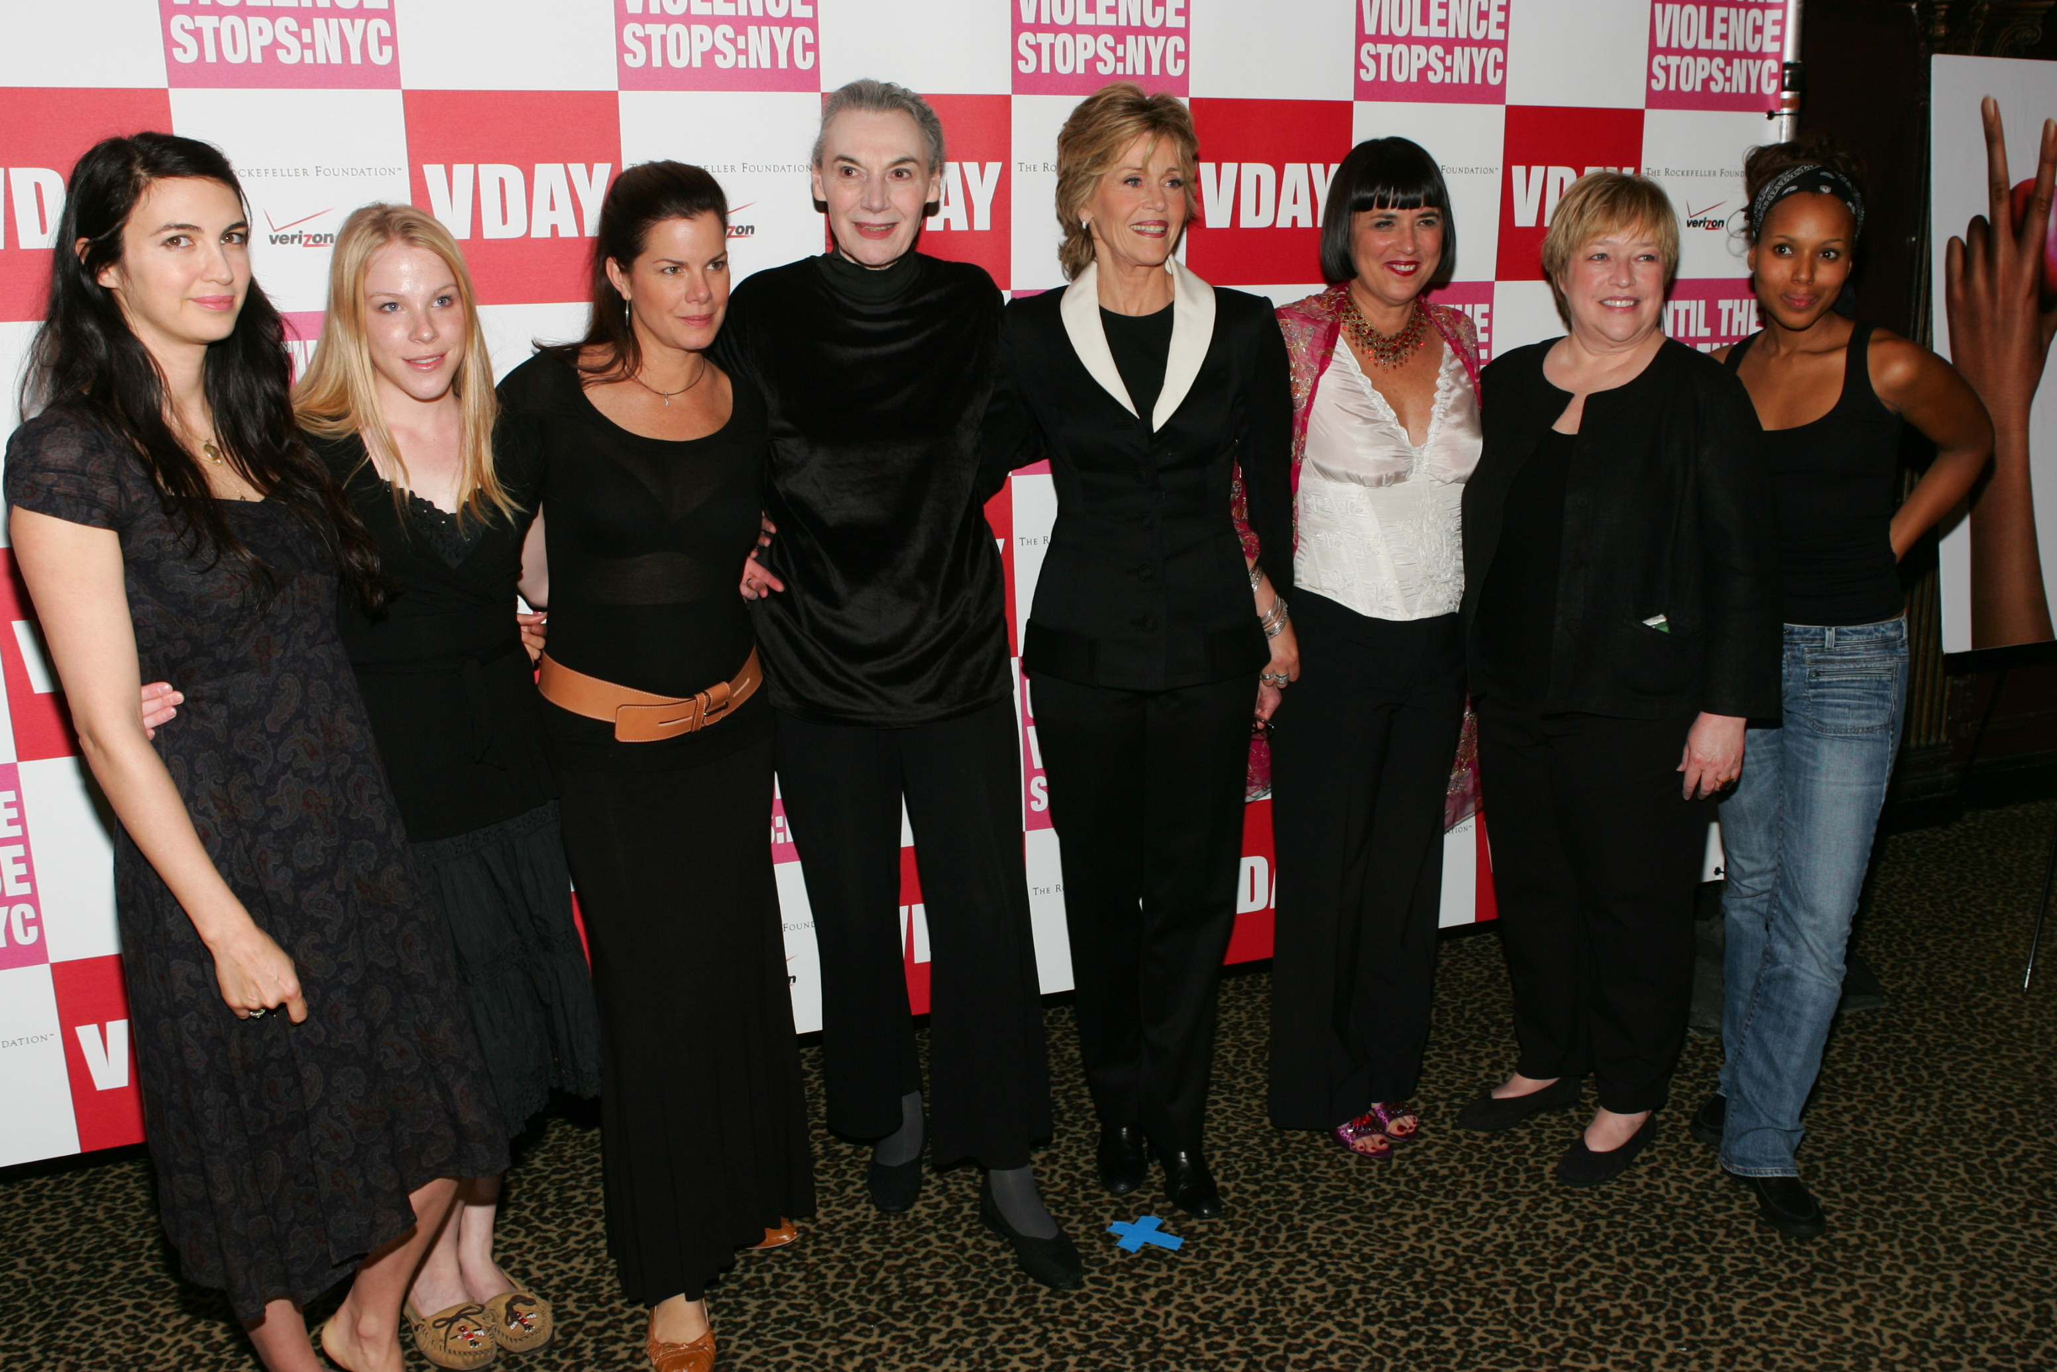

The festival launched on June 12th at Studio 54 with a special, once-in-a-lifetime reading of Eve Ensler's play Necessary Targets about women and war, the violence of dark memories and the enduring resilience of the human spirit. Based on interviews conducted by Eve Ensler with numerous women who survived the civil war in the former Yugoslavia, it was performed by Academy Award winners Kathy Bates, Jane Fonda and Marcia Gay Harden, Emma Myles, Shiva Rose,

Tony Award winner Marian Seldes, Kerry Washington and included a vocal performance by Sussan Deyhim. The reading was directed by Michael Wilson.

The play set the stage for the festival, bringing the global nature of V-Day’s work with women in conflict zones to the forefront and connecting it to the New York audience. As a centerpiece, the play initiated a larger dialogue about the little publicized aftereffects of war on women in particular. When we think of war, we think of it as something that happens to men in fields or jungles, we think of bombs and snipers. But war is really a consequence – the effects of which are not known or felt for months, years, and generations. It is after the bombing, after the snipers, when the real war begins.

Panel: Women In Conflict Zones
June 13 at the Ford Foundation

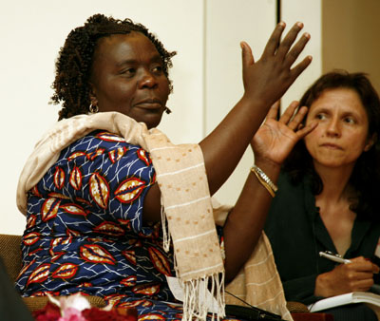

On June 13th, the day after the festival launched with Necessary Targets, a panel of extraordinary women activists from conflict zones (including Bosnia, Burma, Cambodia, Egypt, Lebanon, Rwanda) took up the issues of the play and launched V-Day's 2007 Spotlight Campaign: Women in Conflict Zones.

For women, not just during war but for decades to come, armed conflict means escalated military, sexual, and domestic violence, lack of security as a displaced person or refugee, and vulnerability to sex traffickers and coerced prostitution even by the peacekeepers themselves. Given the 21st century's escalating armed conflicts, impunity for wartime sexual violence cannot be tolerated. As patterns of wartime rape and sexual violence continue today in places such as Sudan, Congo, Darfur and Iraq, it is paramount to expose and condemn these crimes through international media coverage and public outcry and efforts in our communities themselves.

By combining the session of international activists with a celebrity performance of Necessary Targets and a citywide festival, V-Day ensured a high profile event that delivered exposure to women's leadership in conflict zones. The international panelists were individuals who have experienced the pain of war and the trauma that follows in a conflict zone and have fought for justice. They provide leadership for peacemaking and ending violence against women in their own countries. This panel was co-sponsored by Mama Cash and The Ford Foundation.

A Memory, A Monologue, A Rant and A Prayer: Writers on Violence Against Women and Girls
June 19 at Hammerstein Ballroom

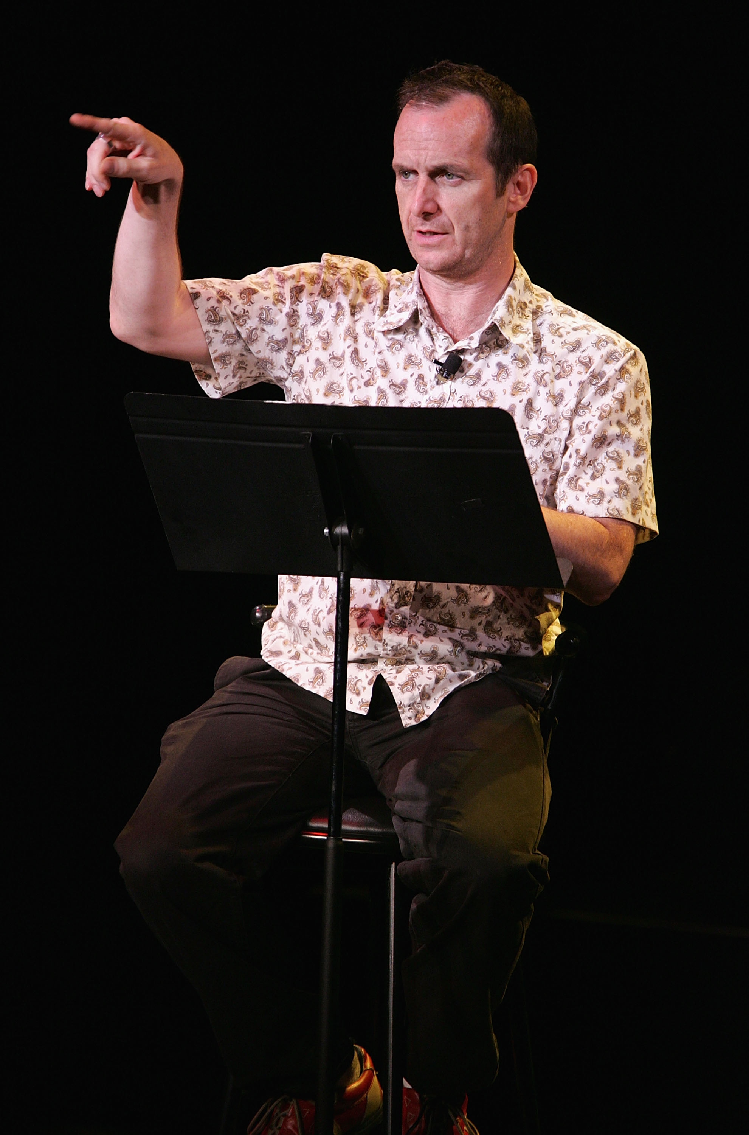 | World renowned writers contributed original pieces addressing the issue of violence against women, bringing their particular vision, talent and take on the issue with performances by celebrated actors including La Chanze, Sarita Choudhury, Rosario Dawson, James Lecesne, Charlotte Martin, Cynthia Nixon, Denis O'Hare, Victor Rivers, Isabella Rossellini, Lois Smith, Marlo Thomas, Nia Vardalos, Kerry Washington, and more. Beyond the time constraint of five minutes or less and the theme of women and violence, each monologue was for the writer to realize. No constructs, restrictions, or rules. A fantasy of a world where there is no violence. A poem about the physics of a slap. A memory. It could be a rant, a speech, a scene, a meditation or a prayer. Exceptional actors performed each monologue under the direction of Joe Mantello, Loy Arcena, Oskar Eustis, Loretta Greco, Kenny Leon, Pamela MacKinnon, Michael Mayer, Leigh Silverman, Claudia Weill, and more. Singer-songwriter Charlotte Martin performed throughout the evening, and contributed an original song written for the event. Writers from around the world included: Edward Albee, Tariq Ali, Hanan al-Shaykh, Erin Cressida Wilson, Kimberlé Crenshaw, Michael Cunningham, Ariel Dorfman, Edwidge Danticat, Michael Eric Dyson, Eve
Ensler, Carol Gilligan, Suheir Hammad, Carol Kaplan, Michael Klein, Deborah Copaken Kagan, Nicholas Kristof, Mark Matousek, Susan Miller, Susan Minot, Robin Morgan, Kathy Najimy, Lynn Nottage, Anna Deavere Smith, Alice Walker, Jody Williams, and Howard Zinn.

Any One Of Us: Words From Prison

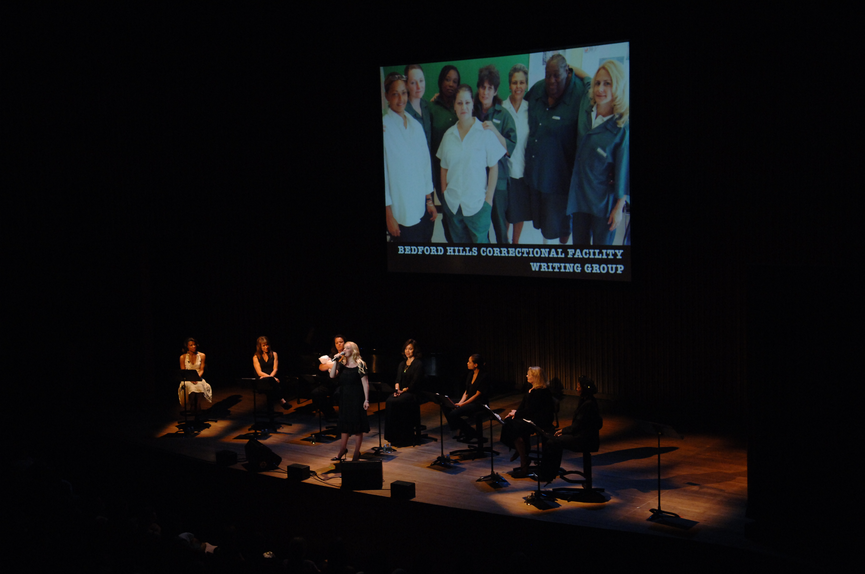

June 21 at Alice Tully Hall at Lincoln Center
More than 90% of women in prison have experienced violence in their own lives. This sold out performance of Words From Prison revealed the connection between women in prison and the violence that often brings them there. Presented in conjunction with the American Civil Liberties Union and the New York Civil Liberties Union, this event brought forth raw voices of fierceness and honesty written by women from prisons across the nation and performed by great actors, moving forward toward healing, understanding, and change, ultimately impacting laws and treatment of incarcerated women.

Outreach was made to women in major federal prisons for their stories, including Bedford Hills Correctional Facility, Scott Correctional Facility for Women, Broward Correctional Institution for Women, and the San Francisco County Jail #8. Images from Deborah Luster’s book One Big Self: Prisoners of Louisiana provided the visual backdrop for the evening. The event was a benefit for the American Civil Liberties Union, New York Civil Liberties Union, the Women In Prison Association, and the Women In Prison Project. Kimberlé Crenshaw, Rosario Dawson, Mindy McCready, Rosie O’Donnell, Phylicia Rashad, Kemba Smith, Betty Gale Tyson, Angie Wilson, Michael Eric Dyson, and more performed under the direction of Rhodessa Jones. The evening was sponsored in part by The New York Women’s Foundation.

It’s Hard Out Here For A Girl/Brooklyn Represents: Language and Sound
June 25 at Brooklyn Museum

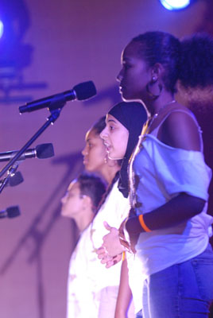 | Toni Blackman, Suheir Hammad, Georgia Me, Ishle Park, DJ Reborn, Maysoon Ziyad, Urban Word and the Community Word Project joined V-Day to speak out, act out, and bring the Brooklyn community together to create a safe haven for women and girls. The sold out evening raised funds and awareness for The Brooklyn Family Justice Center.

Men@Work: Men Working To End Men’s Violence Against Women And Girls
June 24, Columbia University
In the spring of 2006, V-Day convened a committee, V-Day Men, which included Byron Hurt, David Jones, Jackson Katz, Don McPherson, Sanjay Rawal, Victor Rivers and Quentin Walcott. For UNTIL THE VIOLENCE STOPS: NYC, V-Day Men developed a workshop involving community leaders, activists and multimedia tools. In addition to a core curriculum breaking down the issues surrounding the roots of violence toward women, a series of creative tools was employed. The groundbreaking workshop -Men@Work: Men Working To End Men’s Violence Against Women And Girls - included topics such as: Redefining Masculinity; Recognizing Family Violence; Beyond Beats and Rhymes-An Exploration of Sexism, Homophobia and Misogyny in Hip Hop; Fathering-Finding the Tools for Breaking the Cycle of Violence, and Becoming a Leader in Your Community to End Violence Against Women. V-Day Men was sponsored in part by the Avon Foundation.

Run Until the Violence Stops
June 27 in Prospect Park
On a beautiful summer evening, June 27th in Brooklyn’s Prospect Park, over 2000 women and men participated in V-Day’s Run Until The Violence Stops. The event brought together an energetic and enthusiastic crowed of V-Day supporters old and new, all of whom where fueled by the mission to end violence against women and girls. Gun survivor and official “Millionth Face” in Amnesty International’s Control Arms Campaign Julius Arile Lomerinyang from Kenya won the 5K race in just over 16 minutes.
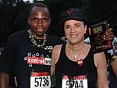

With celebration in the air, this event in the heart of Brooklyn proved to be the perfect ending to an amazing festival, encouraging and empowering everyone to walk or run into the world and reclaim peace.

MEDIA

UNTIL THE VIOLENCE STOPS: NYC received extensive coverage from local, national and international press. The breadth and scope of the festival can be illustrated in its coverage. Newsprint impressions were made as far away as Kingdom of Bahrain, Italy and Mexico, and within the U.S. from California, to Oklahoma, to Texas to Connecticut.

Following is a snapshot of media outlets that covered UNTIL THE VIOLENCE STOPS: NYC:

Television:
Entertainment Tonight, Extra, Access Hollywood, Al Jazeera, Democracy Now, Good Day New York, WCBS TV 2
Radio:
Air America, Democracy Now, Voice of America, BAI, KYW News Radio 1060, WNYC, WBLS
Print:
AM New York  Amarillo Globe-News  Asbury Park Press  Associated Press  Athol Daily News  Bahrain Tribune (Kingdom of Bahrain)  Brooklyn Daily Eagle  Daily Commercial  Daily Times  Detroit Free Press  El Nuevo Dia  Electronic Urban Report  El Diaro  Gawker  Gothamist  Greenville News  Hawk Eye  Home Reporter | Hour  Journal News  La Republica (Italy)  L Magazine  Market Watch  Merced Sun-Star  Metro New York  Morning Call  Morning News  Muskogee Phoenix  New York Amsterdam News  New York Beacon  New York Daily News  New York Runner  The New York Times  News-Times  News-Times  Northwest Herald  Patriot News | People Magazine  Playbill  Pop Matters  Post and Courier  Post-Tribune  Records Herald  Republican  San Antonio Express News  Santa Cruz Sentinel  Shirley Oracle  Star Ledger  State  Staten Island Advance  Sunset News  Telegram & Gazette  The Times  Times  Time Out New York  Womens eNews | World Magazine

PATRONS, SUPPORTERS, AND OUTREACH SPONSORS:

In addition to our sponsors, UNTIL THE VIOLENCE STOPS: NYC was generously supported by the following:
Supporters:
Carole Black
BET Networks
Robyn Goodman
Hercode.org
One World Fund
FaithandFeminism.org
Francie Pepper
Abigail Pogrebin & David Shapiro
Marie Cecile Renauld
Howard & Sharon Socol
I. Chera Sons Foundation
Fran and Barry Weissler

Patrons:
Altria
Donna Karan
Mama Cash
New York Women’s Foundation
Suze Orman
Sarah Peter
Carole and Lisa Pittelman
schoolery design inc.
The Joe Torre Safe at Home Foundation
The Ford Foundation

Outreach Sponsors:
(Outreach Sponsors promoted the festival on their websites, via email and to their audiences.)
Altar Magazine
Bitch: Feminist Response to Pop Culture
The Brooklyn Rail
Equality Now
Feminist.com
Girls in Government
National Coalition Against Domestic Violence
National Domestic Violence Hotline
NOW - NYC
OMEGA Institute
Safe Horizon
Sheila Wellstone Institute
Women’s Funding Network

THANK YOU

UNTIL THE VIOLENCE STOPS: NYC, conceived and directed by Eve Ensler, was a result of the hard work of a small number of V-Day staff and many dedicated volunteers:

V-Core
Jerri Lynn Fields Executive Director/Festival Executive Producer
Kate Fisher Media and Communications Associate/Festival Associate Creative Director
Cecile Lipworth Director of V-Day Worldwide Campaign/Director of Grassroots Festival
Shael Norris Director of V-Day College Campaign/Festival Talent Manager
Tony Montenieri Executive Assistant to Artistic Director/V-Day Men Coordinator
Hibaaq OsmanV-Day Special Representative: Asia, Africa, and the Middle East/Karama Chair
Allison Prouty Associate Artistic Director/Festival Producer
Amy Squires V-Day Web and Online Community Director/Festival Website Producer
Susan Celia Swan Director of Media and Communications Advisor/Festival Creative Director
JFM 2 Productions -

Festival Event Management and Fundraising
Elizabeth Broderick Project Assistant | Alexandra Diaz Project Coordinator, A Memory, A Monologue, A Rant and A Prayer/ Any One of Us: Words From Prison | Fiona Galloway Project Coordinator | Amanda Martignetti Project Director | Joan F. Morgan President | Rhiannon O'Leary Project Coordinator, Necessary Targets/ It's Hard Out Here For A Girl | Brenda Wayne Ticketing Manager
Festival Production Staff
Tony Melchior Production Manager | Shanthi Stone Associate Production Manager | Paul Bevan Audio Designer/Engineer | Doug Baker Assistant Production Manager | Christian Manganelli Assistant Production Manager | Nicoletta Gacos | Reva Minkoff
Festival Associate Producers
Jennifer Chambers Grassroots Coalition Coordinator | Jade Guanchez Festival Coordinator | Lanna Joffrey Necessary Targets | Kristin Lalka A Memory, A Monologue, A Rant, and a Prayer / Any One of Us: Words From Prison | Purva Panday Festival Associate Producer | Sarah Vaill Special Advisor to Hibaaq Osman, V-Day Special Representative to Asia, Africa and the Middle East | Asha Veal It's Hard Out Here For A Girl
Media & Communications Team
Matt Dunn | Caitlin Fitzpatrick | Mariko Kawachi | Brae Marketo | Teresa Russell | Laura Schwartz | Wendy Shanker | Cathryn Swan | Cassandra Del Viscio Press/Talent Coordinator | Susan Vargo Talent Coordinator
Talent Assistants
Valerie Della Cerra | Katheryn Diehl | Roberta Emerson | Ella Golding | Katherine Norris | Nancy Rafi
Hair & Make-Up Artists
Hair/Makeup Ryan Cotton/Oscar Bond Salon Hair and Makeup Supervisor
Jeff Chastain | Jessica DeLeon | Jenn Jorge Nelson | Cassandra Keating | Carrie Richmond | Julie Teel | Tomasina Dina Sliwiak | Jason Wilkerson
V-Administration And Finance
Benita Kline Awards Manager | Hal Leventhal Director, Finance and Administration | Heather Moseley Administrative Assistant | Selina Williams Accounting Manager
Design
Invitation, printed program, and sponsor package design Lili Schwartz
Invitation, printed program, and sponsor package printing Oser Press
Festival Ad Campaign Design schoolery design, inc.
PhotographyGetty Images
Festival Vendors
Joan Steinberg, Match Catering | Bob Rendon, Promix/PRG
Special Thanks
Janet Abrams | Tara Agnesini | Laura Amazzon | Philip Boag | Georges Borchardt | Zachary Borst | Jennifer Brajevich-Ignacio | Tom Calandrillo | Greg Caliguiri | Tiffany Canfield | Bernie Telsey Casting | Judy Corcoran | Alana Dasilva | Cody Dobyns | Mollie Doyle | Jody Elff | Katie Ensler | Dennis Frankie | Getty Images | Maris Goodstein Eric Gurian | Elizabeth R. Harder | Michele Karlsberg | | Johnny 'Hatz' Krunchinsky | George Lane | James Lecesne | Rachel Lehmann-Haupt | Sarah Jane Leigh | Celine Little | Brett Loughry/TKO Production Services | Brad Mackie Prism Theatrical Lighting | Jeff Marzigliano | Sarah Miles | Dan Mineo, Office of Joel Lubin, CAA | Otis Morgan | Jennifer Prather | Kim Rosen | Joseph Rossewog | Erin Russell | Larry Sacharow | Charlotte Sheedy | S.I.R. | Shawlena Small | Larry Smith | Aarti Tandon | A'yen Tran | Michael Weinstein | Tiasia Williams | Leiba Young | Teodora Zareval
UTVS: NYC COMMITTEE
Honorary Chairs: Laura Ensler | Patricia E. Harris
Robyn Goodman | Todd Haimes | Harriet Leve | Cari Ross | David Stone | Meryl Streep | Fran Weisler
V-DAY EXTENDS A VERY SPECIAL THANKS TO:
Laura Ensler, Katherine McFate, Joan Stein and Jennifer Chambers.

Photos: Getty Images For V-Day



